

**UNIVERSITY OF PETROLEUM AND ENERGY STUDIES**

**School of Computer** **Science**

**2020-21**

**GRAPHICS AND ANIMATION TOOLS LAB**

**Faculty: Dr. DURGANSH SHARMA**

**Assistant Professor**

**Department of Cybernetics.**

**School of Computer Science, UPES**

**Submitted By:**

**Name- Manushi Kapoor**

**Roll no-R100217037**

**Batch-B1**

**Semester- 7**

**Course-B.tech. CSE-OSOS**

**Sap Id- 500062100**

EXPERIMENT 1

**AIM -** Installation of GIMP and BLENDER

**STEPS TO BE FOLLOWED FOR INSTALLATION –**

1. **GIMP –**

* Go to gimp official website and click on Download GIMP 2.10.20 directly.

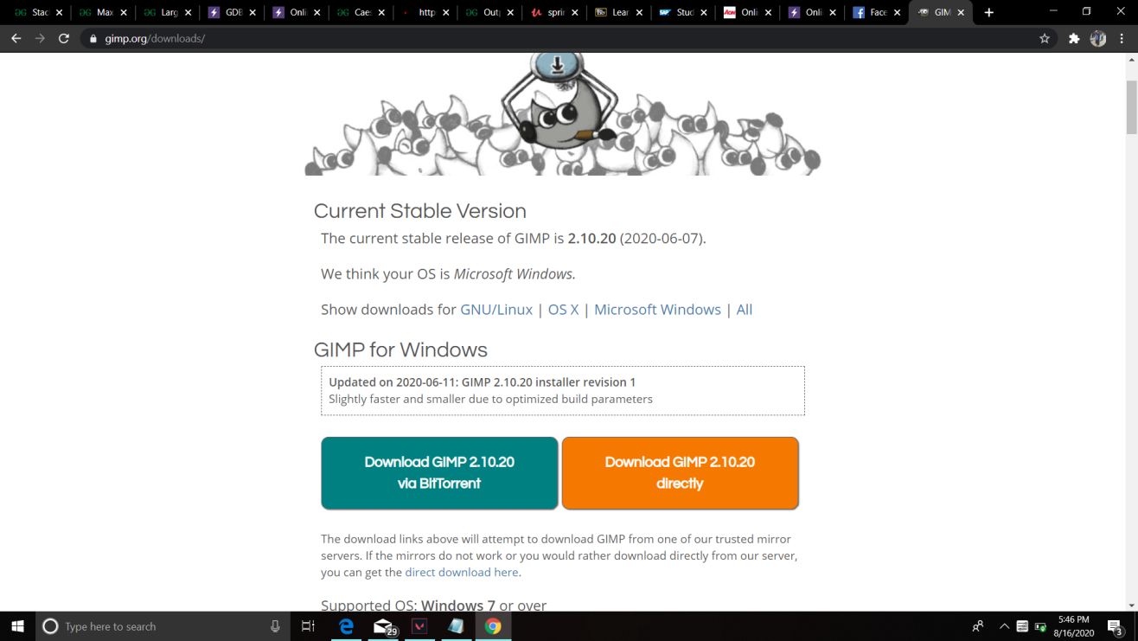

* A setup window for gimp will open up after the complete download of exe file. Click on next , choose desired location of installation and click on install.

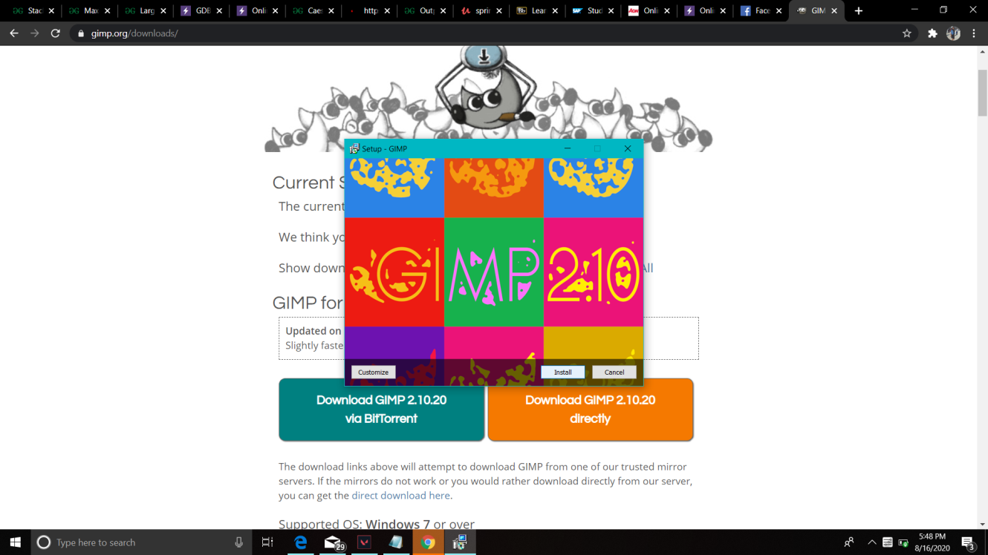

* Click on finish to complete the installation.

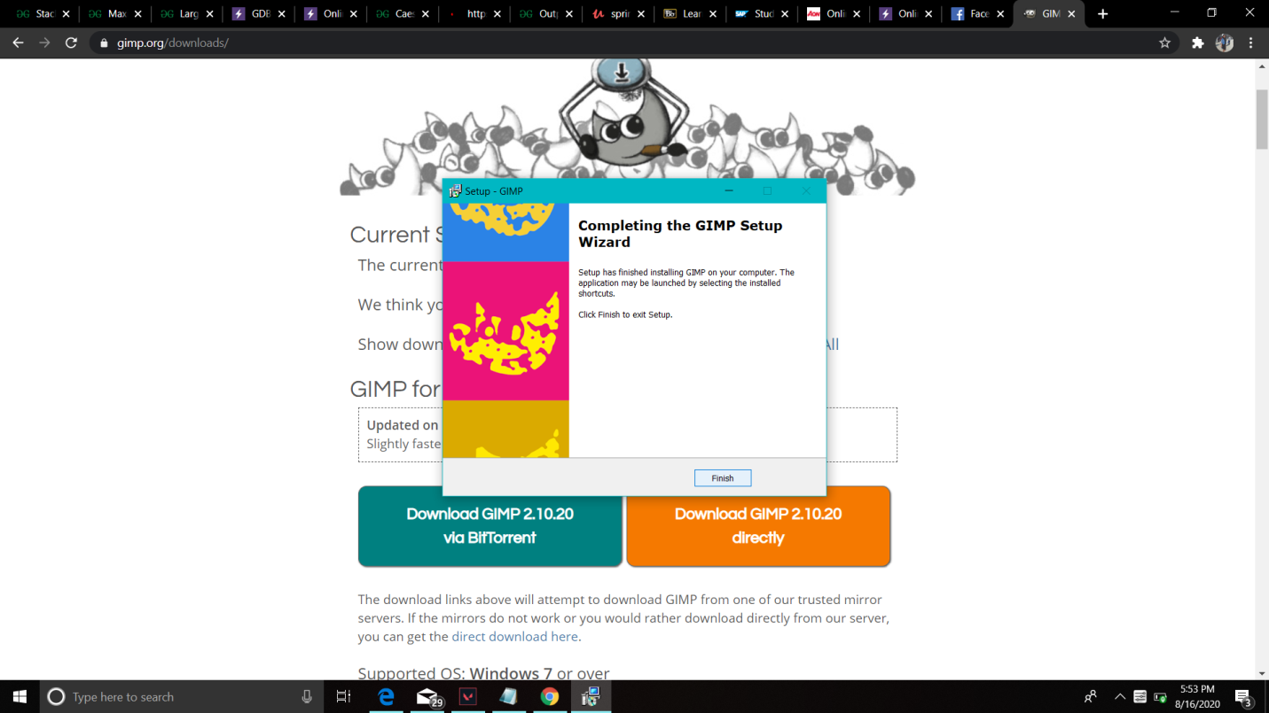

* GIMP will be installed. Open the application. It will look like this -

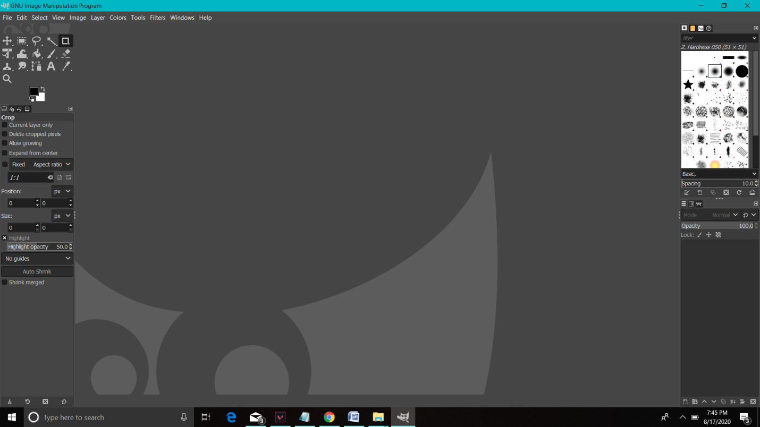

1. **Blender –**

* Go to official website of blender and click on Download Blender 2.83.4 .

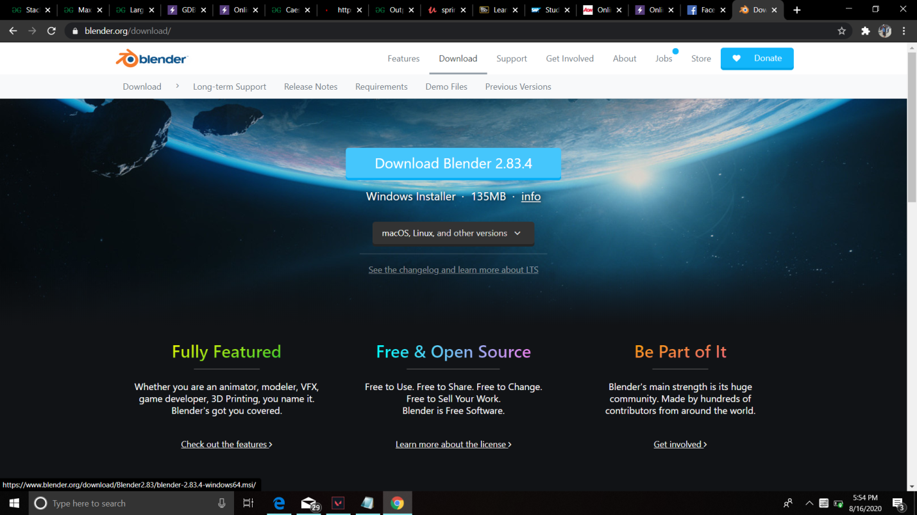

* After complete downloading of exe file, Blender setup wizard will open up. Click on next.

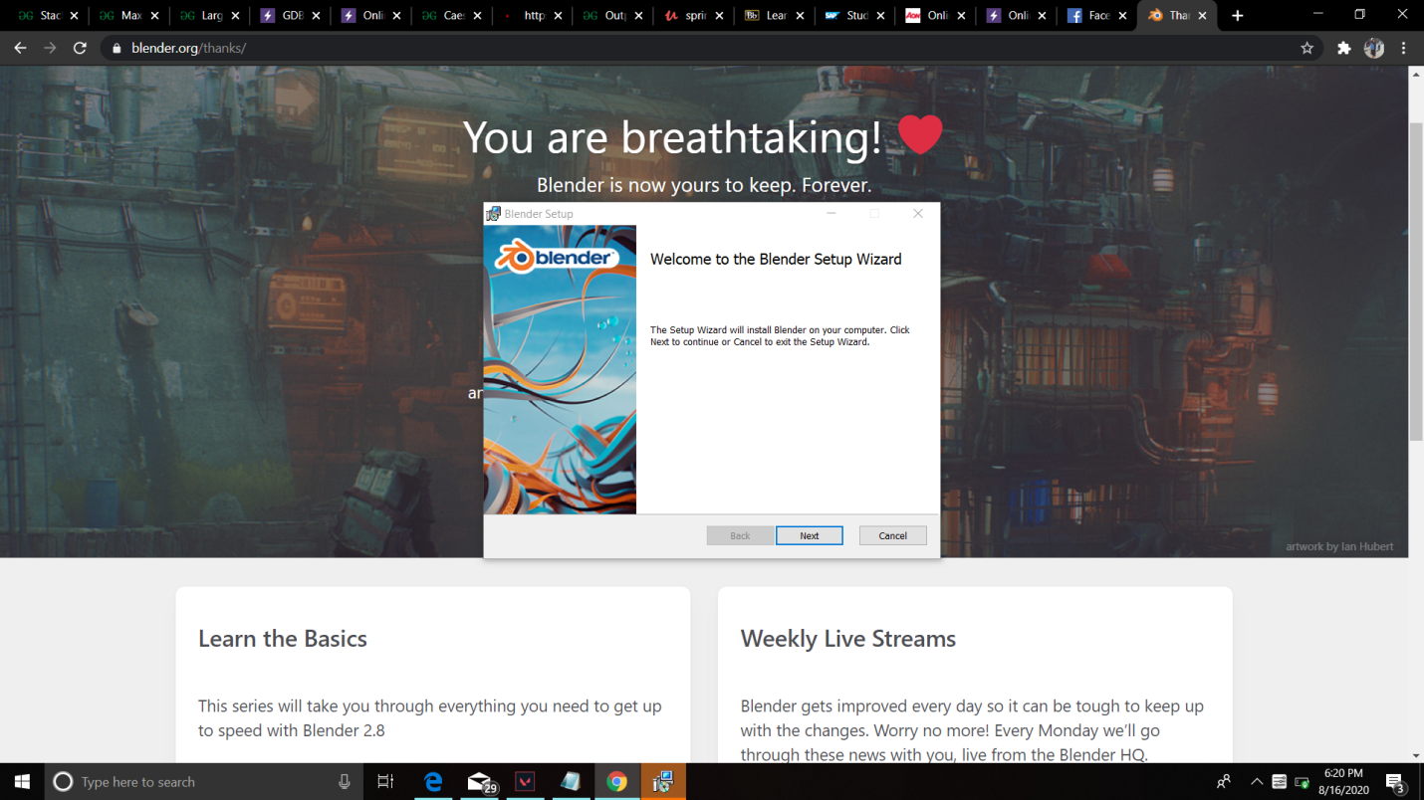

* Accept the terms in the license agreement and click on next. Then, click on install.

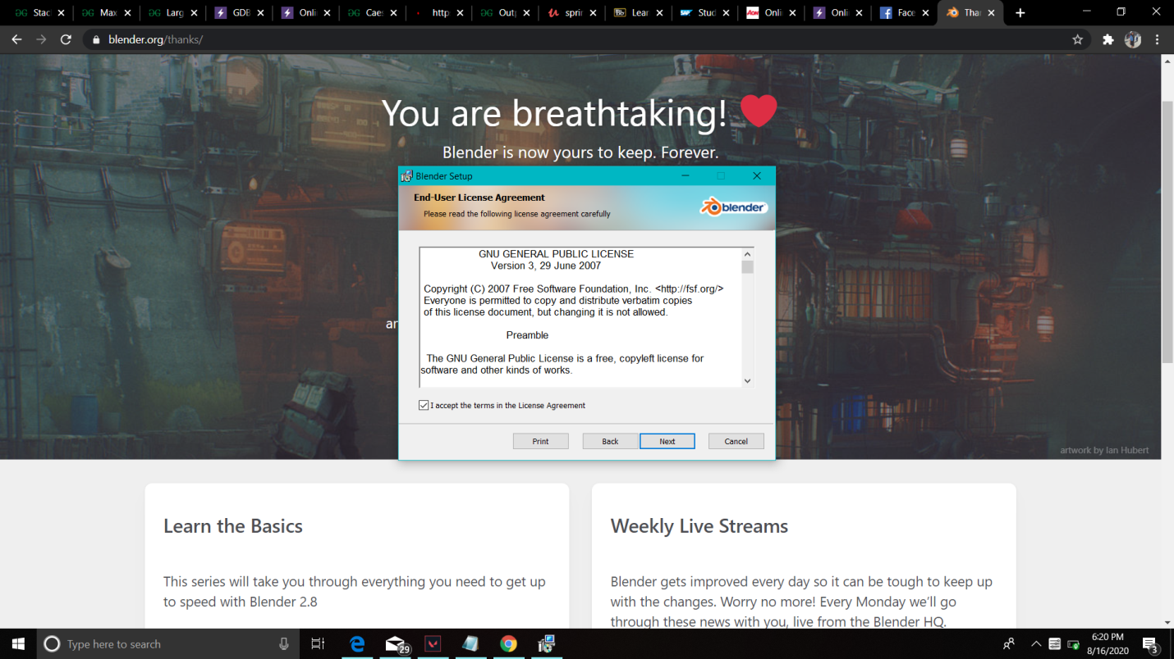

* Finally, click on install.

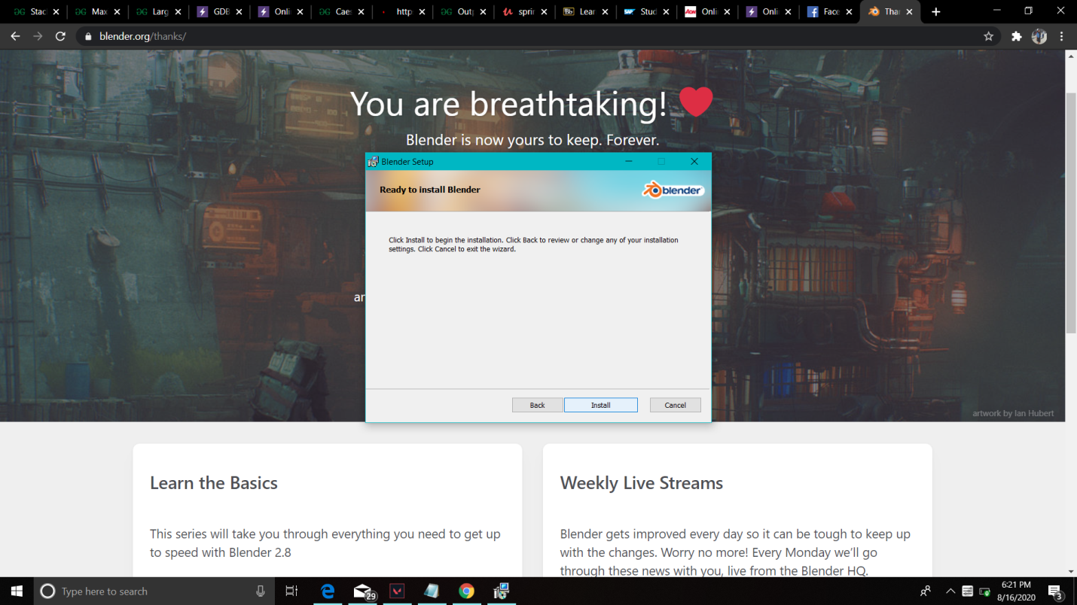

* Blender will be installed. Open the application. It will look like this -

